

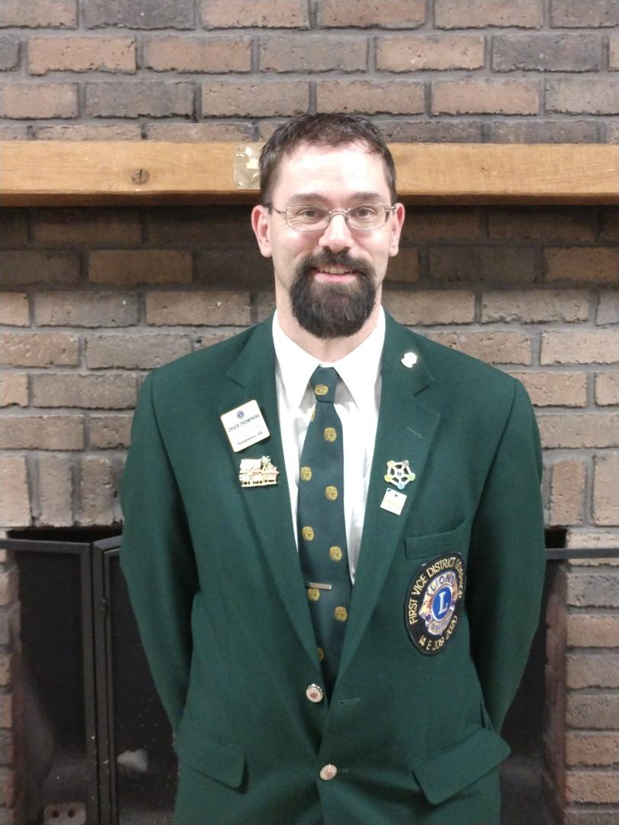

**Delmont Lions Club  
PO Box 52  
Delmont, PA 15626  
724-836-1490**

**Chartered November 3, 1944**

Fellow Lions, Lionesses, and Leos;

On behalf of the members of the Delmont Lion Club, I would like to nominate 1st Vice District Governor Chuck Thompkins as a candidate for the office of District Governor of District 14-E for the 2020-2021 Lions year.

Lion Chuck joined the Delmont Lions Club in June 2012. Lion Chuck was a member of Boy Scout Troop 218 in Slickville who earned the rank of Life Scout before his troop disbanded. Lion Chuck is currently an Assistant Scoutmaster with Boy Scout Troop 211 in Delmont which the Delmont Lions Club sponsors. He has served the club as 3rd, 2nd, and 1st Vice President, Club President, has sat on the Board of Directors from 2013-2018, is co-chair of the Pancake Breakfast Committee, co-chair of the Apple & Arts Festival, co-chair of the Delmont Lions Annual Car Cruise, was very involved with the clubs recycling efforts, assists with all club activities, and has overseen projects such as building a handicap ramp & installing a park bench in the Delmont Park-let.

Past District Governor Aaron Slezak appointed Lion Chuck to Zone 1 Chairperson in January of 2017 after completing a 6 month zone chair shadowing program. Lion Chuck currently serves as the Club Support Team Chair, and has served as the District 14-E bowling Tournament Co-Chair for 2 years, and was involved with the District Convention Planning Committee, the Youth Talent Show, and the Multiple District State Convention Planning Committee for 2017.

Lion Chuck also attended the Regional Lions Leadership Institute held in Harrisburg, PA in November 2016 & the USA Canada Forum in Columbus, Ohio in September 2018.

Lion Chuck has been recognized by his club as a Lion of the Year, & has recognized for perfect club attendance as well. He has also been recognized by the District as a Melvin Jones Fellow.

Lion Chuck resides in Greensburg in Salem Township with his wife and partner-in-service Lion Amy. They have two children: Lion Sarah (husband-Lion David), and Lion Ryan.

It is my honor and privilege to submit the nomination of Lion Chuck Thompkins to District 14-E for the position of District Governor.

Yours in Lionism,

Amy L. Thompkins

Delmont Lions Club Secretary