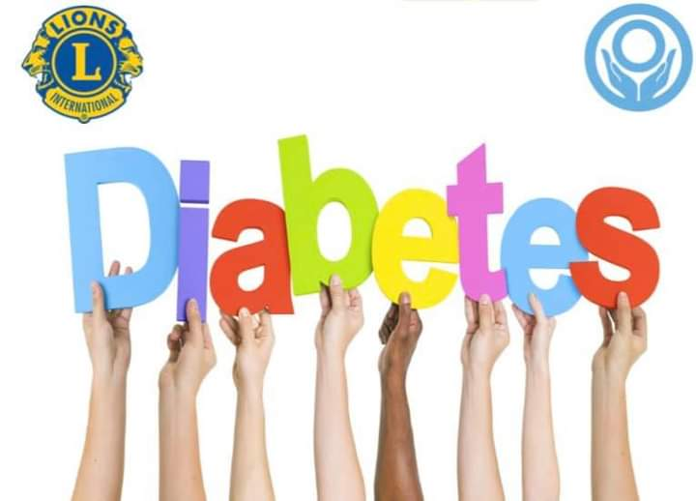
The Lions Diabetes Board of Allegheny and
Westmoreland Counties (LDBAW)

November, 2021

Dear “Christmas with the Lions” Donor:

On Saturday, December 17, 2021, the Lions Diabetes Board of Allegheny and Westmoreland Counties (LDBAW) will be sponsoring our “Christmas with the Lions” Dinner Dance at the American Legion in White Oak.

Your support is needed now, more than ever, to help replenish over $21,000 in diabetes medication costs for those who cannot afford their medications at UPMC McKeesport and Westmoreland Hospital. Our Board is committed to ensuring that these patients receive their medications. During the past ten years, our medication costs have exceeded $260,000.

One way for you to help us reach our goal is to send a financial contribution. Another way is to donate a Christmas/holiday basket for our auction. The basket auction is a major part of the proceeds raised for our diabetes patients, and you can also share in the rewards of this event.

It’s been said, that “Giving is not just about making a donation; it is about making a difference.” Of course, this is a fantastic opportunity for you to make a difference in the lives of many of our neighbors. Thank you for your consideration, and may you be blessed abundantly.

Sincerely yours,

Amy Thompkins, Basket Auction Chair (14-E)
(amoose309@yahoo.com)
Lisa Gismondi, Basket Co-Chair
(lisgis67@gmail.com )
PID Cindy Gregg, Vice Chair (14-E)
DG Mary Ann Belles (14-B)
DG Margie Wolff (14-B)
PDG Mary Jane Keller (14-B)
Lion Dee Connor (14-B)
Michele Matuch, Board Chair (14-B)
Carla DeJesus, Diabetes Specialist (14-B)
Michele Axelson, Diabetes Specialist (14-E)

Monetary donations can be mailed to LDBAW, c/o Immediate Past District Governor Chris Raynak, Treasurer, 1006 Harvard Drive, Monroeville, PA 15146

